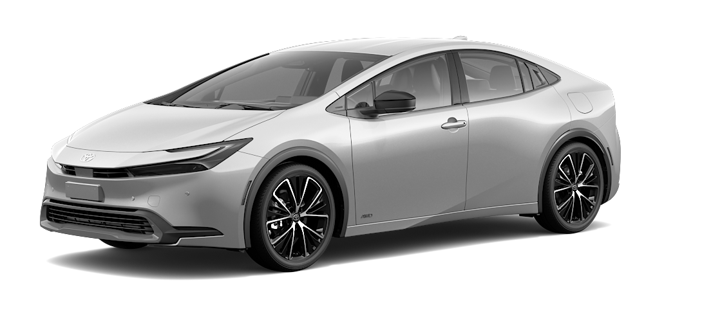

Prius
Hybrid Fuel Source

How interested are you in learning more about this car?

1 Very uninterested
2 Somewhat uninterested
3 Neutral
4 Somewhat interested
5 Very interested

How much do you like this car?

1 Really dislike
2 Somewhat dislike
3 Neutral
4 Somewhat like
5 Really like

If you were on the market for a new vehicle, how likely would you be to purchase this car?

1 Very unlikely
2 Somewhat unlikely
3 Neutral
4 Somewhat likely
5 Very likely

